Log-In and System Navigation

The Messiah College Online Recruitment System (Jobs.messiah.edu) may be accessed either directly via <http://jobs.messiah.edu/hr> or via theEmployee Quicklinks channelonMC Square**.** Mozilla Firefox is the preferred browser.

**How to** Log In

When selecting Jobs.messiah.edu from MC Square, the system will prompt the user for network login information and then will automatically log the user in to the system. Based on the user’s credentials, the system determines the user’s level of access to data and permission to perform work in the application.

For users working outside of the Messiah network, the system is accessible via <https://jobs.messiah.edu/hr/>. Users will be presented with a login page and must select the link for SSO Authentication and enter the Username and Password from the Central Login Page.

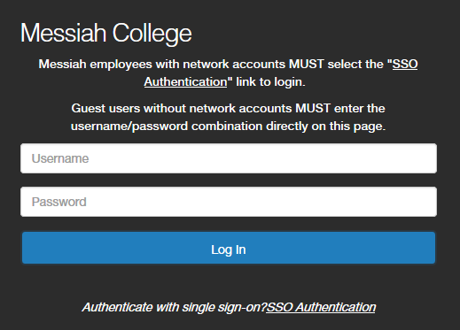

Users requiring additional roles or specific accesses to data should contact the appropriate office listed below (contact information located in the footer of this document) who will review and may revise user role and permissions in the system:

* Office of Human Resources 🡪 administrative, faculty, staff and temporary positions
* Office of Student Employment 🡪 student positions

Once authenticated, the system home page will be displayed using the default user role.

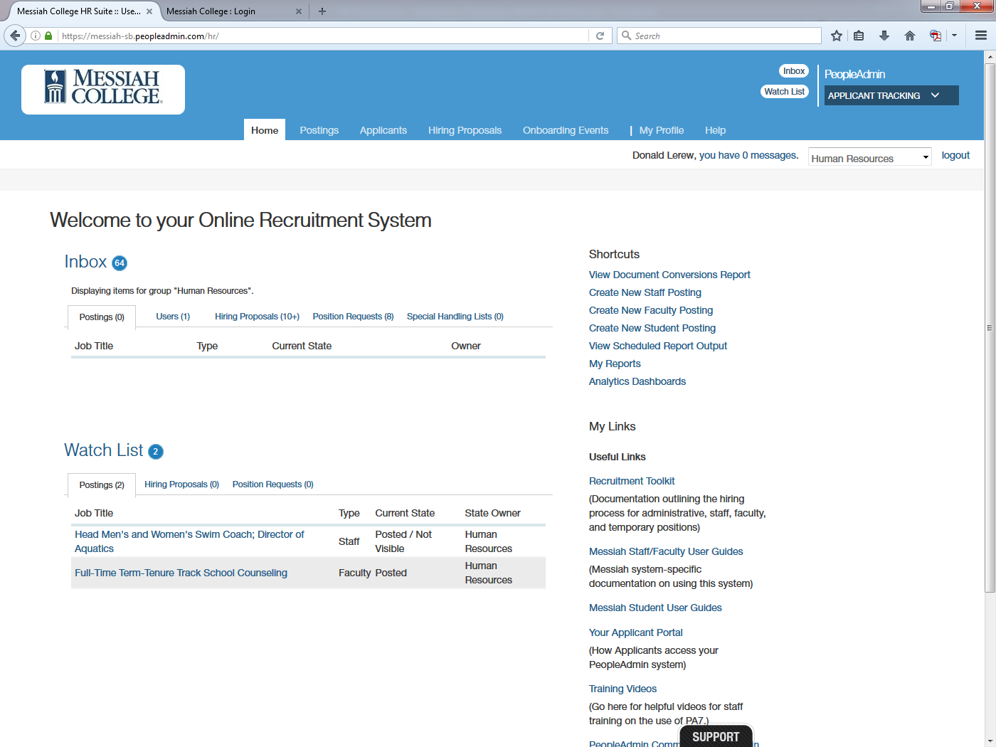

**How to** Select a Role(s)

Based on level of access, the home page will display what the user is permitted to see and actions the user is able to perform in the application. The “default role” will display, although the user may have multiple roles in the system (e.g., Employee and Hiring Manager). To select a desired role, navigate to the top right of the screen and open the role selector drop-down box. The home page display will automatically update based on the chosen role. A confirmation message at the top of the screen will confirm the role has changed.

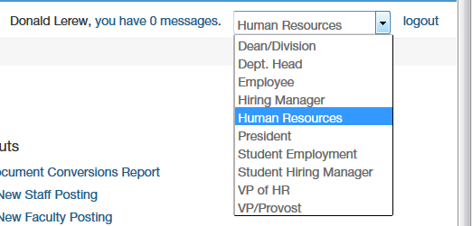

**Navigation in the System**

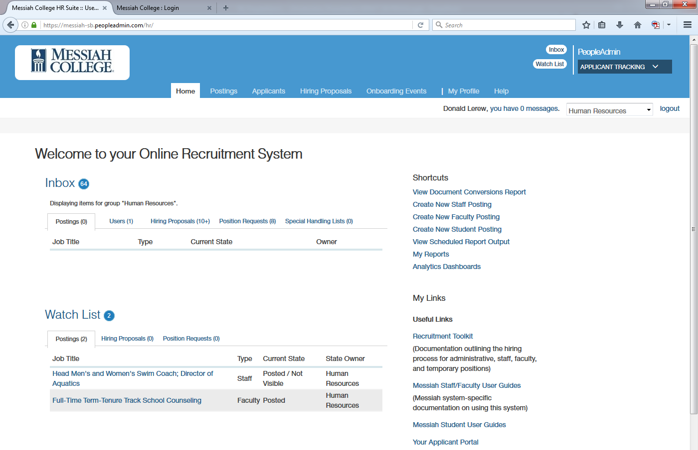

**MODULE SELECTOR**

**MY LINKS**

**SHORTCUTS**

**ROLE SELECTOR**

**WATCH LIST**

**INBOX**

**ALERTS**

**MAIN MENU**

**There are 8 main driving sections of the home page:  
  
*Main Menu*** - located at the top center of the screen. Select any link from the Main Menu to direct to permitted areas of the system (e.g., Postings and Applicants).

***Module Selector*** *–* located at the top right of the screen. Module selection options are based upon the user’s role settings – Applicant Tracking, Position Management, and Admin. The default home page will always be Applicant Tracking

***Role Selector*** – located at the top right of the screen below the Module Selector. The user role permits a user to perform certain duties and view specific information in the system

***Alerts Box*** – located mid screen. Displays system notifications from administrators

***Inbox*** – located below the Alerts Box. Displays items that require the user’s attention (e.g., an action on a posting, or approval of a user)

***Watch List*** - located below the Inbox. Displays items which the user has marked as “Add to Watch List” to allow a quick-view and quick-click access to those items. Can add and remove items from list here

***Shortcuts*** - located at the right of the screen. Shortcuts navigate users to a specific function (e.g., Create Staff Posting)

***My Links*** – located below the Shortcuts Box. Displays specific links to training and other hiring process documentation

**Accessing the** Applicant Portal

Users who wish to view information within the applicant portal can access this information by:

1. Selecting Your Applicant Portal from My Links within the Online Recruitment System
2. Entering the following URL directly into the web browser: <https://jobs.messiah.edu>

**Common Navigation Items**

1. Take Action Menu 🡪 exists on position descriptions, postings, applications and hiring proposals when routing to next/prior step in approval process. Items displayed are based on security role and options available at the time of action.  
     
   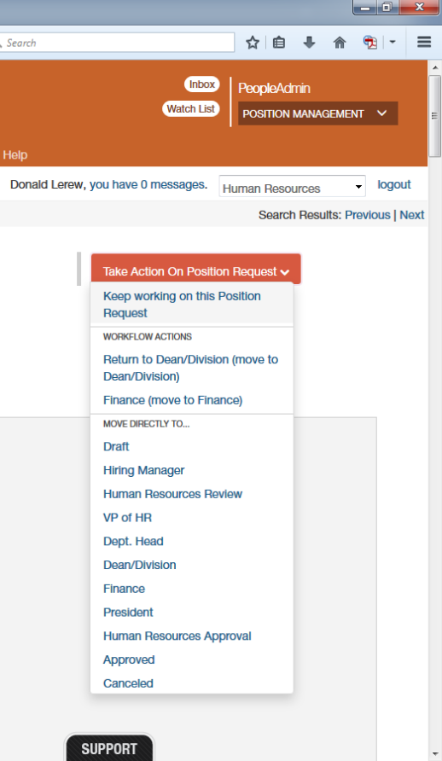
2. Save, Previous & Next Buttons 🡪 appear at the top and bottom of many of the edit screens for position descriptions, postings and hiring proposals. Used to navigate from one page to the next. Note that Next is actually a “Save and Next” functionality.  
     
   

**Searches, Search Results & Saved Searches**

The ability to conduct searches exists across all major areas of the site. For example, a user can search the following: (1) Position Descriptions; (2) Position Requests; (3) Postings; (4) Applicants; and (5) Hiring Proposals.

Each section of the site has a default search that appears based either on the institutional setting on a specific user role. To view and select an alternate available saved search, click on the “Open Saved Search” drop-down selector and select an alternate saved search.

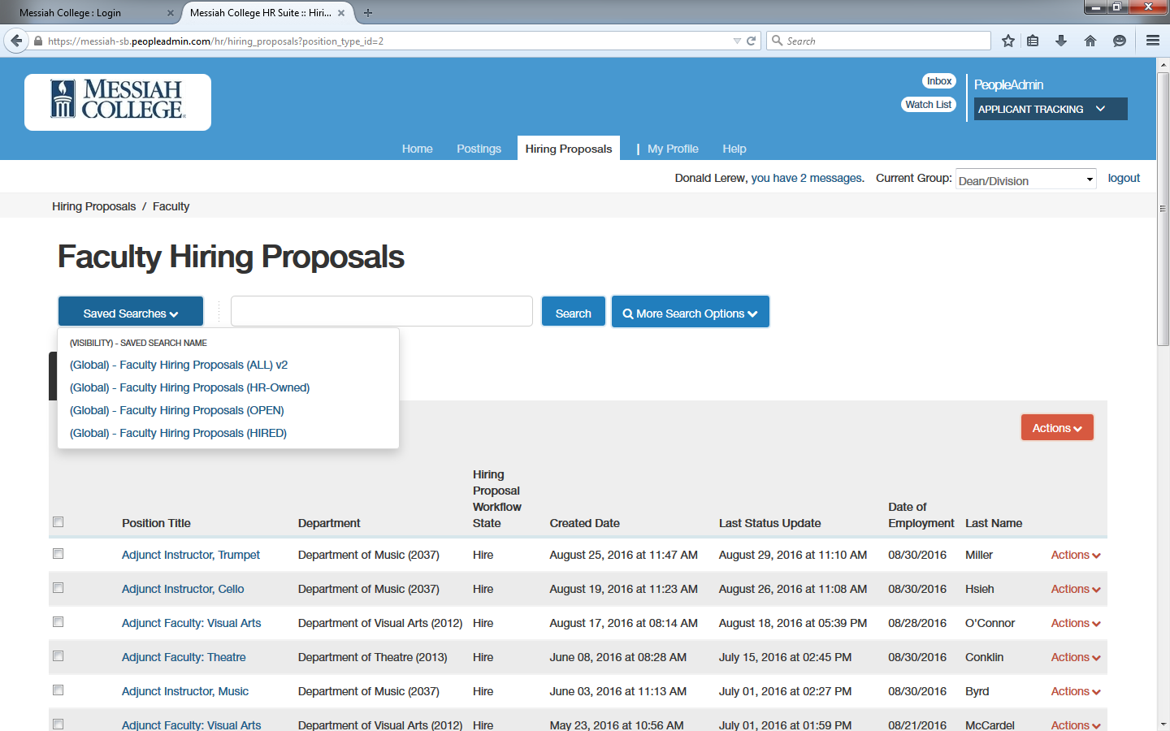

Additionally, users can create and/or their own custom searches using the “More search options” link. Here users can add/remove columns, add/remove workflow states and save a custom search that is available only to the user.

