Search Committee Members

Search Committee Members participate in teams that evaluate candidate applications and attachments and may provide their feedback to the team directly on the applicant record. Search Committees consist of one chair and one or more members. For Staff postings, the Initiator or Hiring Manager do not need to be assigned to a Search Committee to utilize Evaluative Criteria.

Search Committee Members are users who review and contribute to applicant evaluations. Search Committee Members may only see their applicant evaluations. On the other hand, Search Committee Chairs may review and contribute to applicant evaluations. And, Search Committee Chairs may see all applicant evaluations, contributed by the Search Committee members.

**How to** Log InIf you are a Search Committee Team Member or Chair, you are an employee of Messiah College and may access the Messiah College Online Recruitment System from MCSquare from the Jobs.messiah.edu in the Employee QuickLinks channel. Upon entry, you will *not* need to provide a login and password.

If you are accessing the system outside of the Messiah College network, the system is accessible via <https://jobs.messiah.edu/hr/>. You will be presented with a login page and must select the link for SSO Authentication and enter your Username and Password from the Central Login Page.

**How to** Select Your Role

Select the Search Committee role from the role selector drop down box. After you have selected your role, click on the refresh button to the right . The home page display will automatically update based on your chosen role. The application will notify you that your role has been changed. This will appear in a green notification bar at the top of your screen.



**View Postings and Applicants**

From the home screen, select Postings from the top menu, then choose Faculty or Staff, depending on the position to which you are assigned. You may perform a search, including More Search Options or choose from the list of postings. To select a posting, click on a posting hyperlink or choose to View Posting from the Actions button to the right of the posting information.



To view applicants, click on the Applicants tab from the tab menu. The applicant’s application and any supporting documents will appear. From here, the Search Committee member may:



**Evaluate Applicants**

* Go to the Applicants tab from the Job Posting
* View the applicant/application by clicking on the applicant’s name or by selecting View Application from the Actions link to the far right of the applicant’s name
* Go to the Evaluate Applicant link at the top right

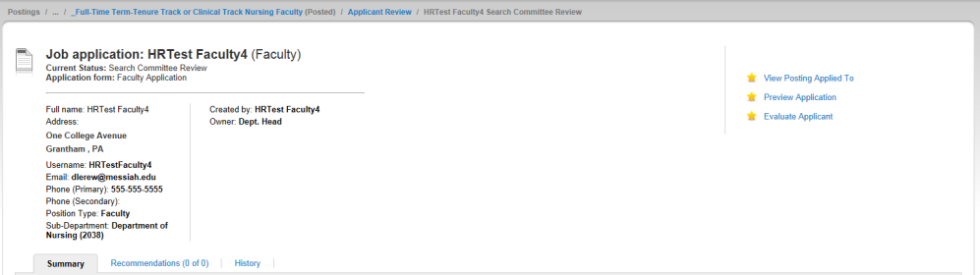

* Answer the evaluative questions and Save; add any comments

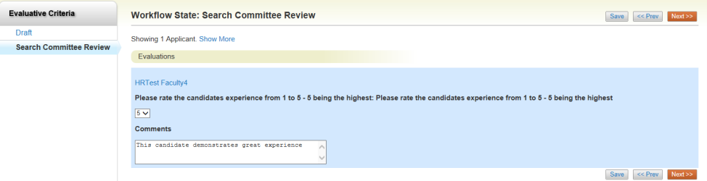

**Download Applicant’s Evaluations**

The Search Committee Chair may download all Applicant Evaluations for comparative purposes

* Navigate to the Summary on the Job Application Screen
* Choose the Actions button and select “Download Applicant Evaluations”

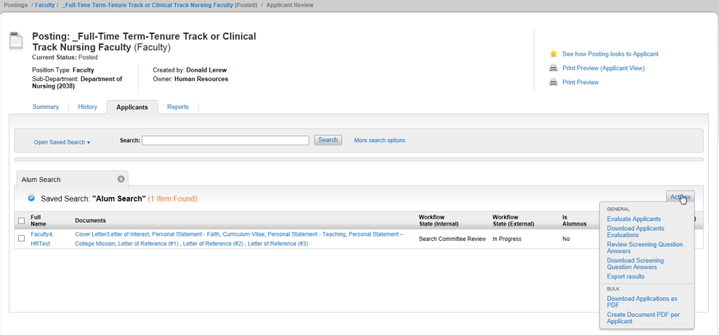

**Review Screening Question Answers and Download Screening Question Answers**

Search Committee Members may Review and Download Screening Question Answers

* Navigate to the Summary on the Job Application screen (see above picture)
* Choose the Actions button and select “Review Screening Question Answers” or “Download Screening Question Answers”. Downloads are exported to Excel

**Print Applications and Supporting Documents**

* Navigate to the Summary on the Job Application Screen

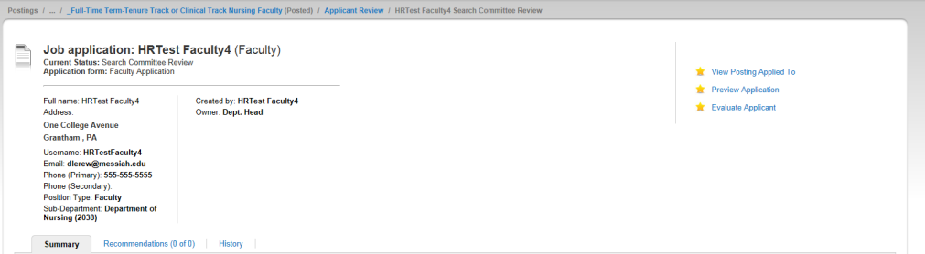

* The application and supporting documentation are found at the bottom of the application page.
* Select “Recreate PDF” to the right of the listed document and print using the File/Print function from the browser
* You may also click on the document name to open and print

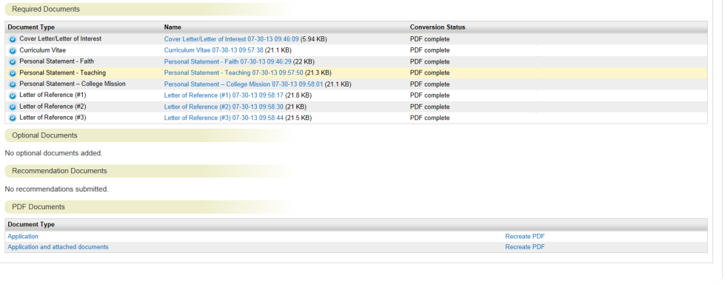

* You can print multiple applicant application by checking the applicant names in the applicant list.
* Select the Actions button and choose Bulk Actions and “Download Applications as PDF”.

|  |
| --- |
| ***! When working with PDFs, the system opens a new browser window to display your document. You must use the “back” button to get back to the system. If you close the PDF document, the Messiah Online Recruitment System will automatically shut down. Note that this is a typical function of any internet-based system that uses PDF as a method for downloading documents.*** |

**Changing Applicant Status**

The Search Committee Chair has the ability to change the status of the applicant. To change the status:

* Select a faculty job posting
* Go to Applicants; Select the applicant for status change
* Choose . Select the desired status

**Viewing Applicant History**

To view applicant history, select the History link from the menu of tabs on the Job Application screen. Search Committee Chairs may include additional comments in this section.



  
  
  