Advanced Functionality – Searching and Saved Searches

The Search feature in the Messiah College Online Recruitment System allows you to drill down on specific information (e.g., position descriptions, postings, applicants and hiring proposals) displayed in lists. Additionally, it allows the creation of ad-hoc, dynamic queries, which may be saved, sorted, filtered, with resulting data exported to Excel for further analysis and reporting. Searches may be performed in all modules and aims at delivering information to the user, quickly.

|  |
| --- |
| ***! Search instructions are the same for all permitted user roles and for varying position types (e.g., Staff, Faculty and Student positions). Output may vary depending on position type and user permissions.*** |

Searches may be performed using keywords and “More search options” for advanced filtering.

**To Search** Position Descriptions**:**

* Navigate to the Position Management module page by selecting Position Management from the drop down select box at the top right of the home screen. Select “Position Descriptions” and position type from the drop down menu

Note that only Staff and Student position descriptions are created and maintained in the system

* Position Descriptions will display

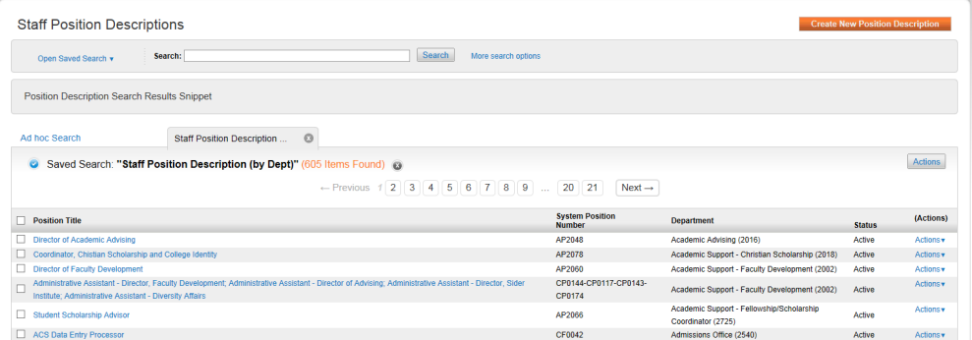

|  |
| --- |
| Search by keyword for simple searches. Simply enter in the keyword and click on the “Search” button. The system will apply your keyword to the Position Title and will display only those that contain the specific keyword in the title  ***! If you know the name of the employee in a position description but not the exact title of the position description, you can enter part of the employee’s name in the search.*** |

* To advance your search and hone in specific detail, select More search options to the right of the search box

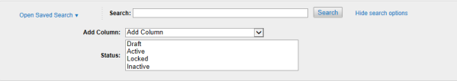

* Here, you will still be able to apply your keyword, but you will also have expanded functionality to include adding columns to your dynamic query. To add a Column, select the column of data from the Add Column drop down box. You may add multiple columns by continuing your selections, while depressing the Shift Key (on your keyboard). Your query will automatically update and expand with the new columns included
* You may also filter Position Descriptions by selecting a Status (e.g., Draft, Active, Locked and Inactive). “Locked” means the Position Description has been taken down for editing and will remain Locked until the status is changed to Active.
* After completing your search parameters, click on “Search” to update your query

**To Search** Job Postings**:**

* Navigate to the Postings page by selecting Postings from the top navigation menu on the home screen. Based on your security access, select Staff, Faculty or Student for type of Postings
* Your default list of Postings will display:

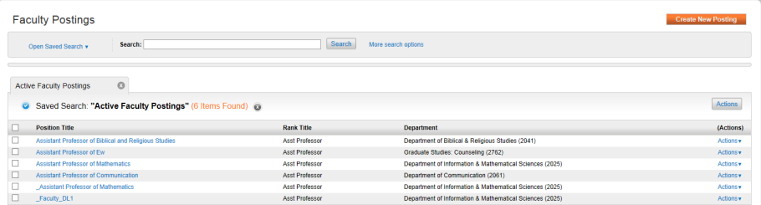

* Search by keyword for simple searches. Simply enter in the keyword and click on the “Search” button. The system will apply your keyword to the Position Title of the Postings and will display only those that contain the specific keyword in the title
* To advance your search and hone in specific detail, select More search options to the right of the search box

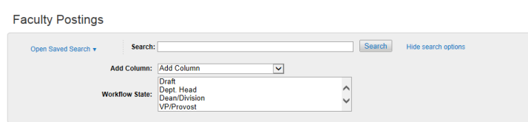

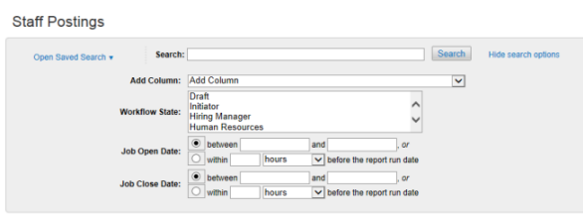

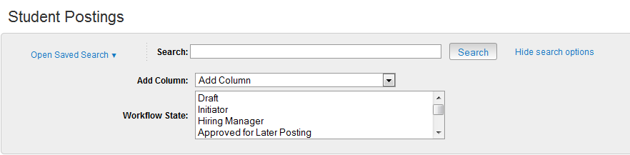

|  |
| --- |
| ***! The More search options for Staff Postings includes additional search fields for optional Job Open Date and Job Close Date to further filter the postings.*** |

* Here, you will still be able to apply your keyword, but you will also have expanded functionality to include adding columns to your dynamic query. To add a Column, select the column of data from the Add Column drop down box. You may add multiple columns by continuing your selections, while depressing the Shift Key (on your keyboard). Your query will automatically update and expand with the new columns included
* Workflow Status, Posting Date and Closing Date are selections for filtering data. Choose any of these or input the appropriate date information to refine the query’s details
* After completing your search parameters, click on “Search” to update your query

**To Search** Applicants**:**

* You may navigate to Applicants in a number of ways:
  + Click on Applicants from the main navigation menu on the home screen and choose which category of applications you would like to view; Applicants at this level are for all Postings in your chosen category
  + Click on a Job Posting and select the Applicants tab from the Job Summary page or from a Saved Search, click on “View Applicants” from the Actions link to the right of the Posting name.

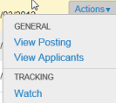

* Your default list of Applicants will display:

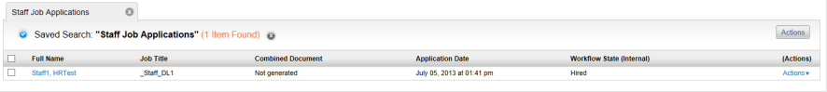

* Search by keyword for simple searches. Simply enter in the keyword (Name) and click on the “Search” button. The system will apply your keyword to the Full Name of the Applicant and will display only those that contain the specific keyword (Name) in the Applicant’s Full Name
* To advance your search, select More search options to the right of the search box

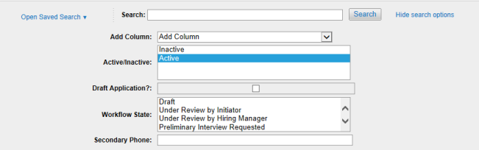

* Here, you will still be able to apply your keyword (Name), but will also have expanded functionality to include adding columns to your dynamic query. To add a Column, select the

column of data from the Add Column drop down box. You may add multiple columns by continuing your selections. Your query will automatically update and expand with the new columns included

* Active/Inactive, Draft Application, Workflow State and Secondary Phone are selections for filtering data. Choose any of these or input the appropriate date information to refine the query’s details
* After completing your search parameters, click on “Search” to update your query

**To** Search Hiring Proposals**:**

* Navigate to the Applicant Tracking module by selecting Applicant Tracking from the top navigation menu on the home screen. You may either open Hiring Proposals from the main menu at the top or access Hiring Proposals as a tab found directly on the Job Posting Summary Screen. Choose your position type
* A list of Hiring Proposals will display  
    
  
* Search by keyword for simple searches. Simply enter in the keyword (Name) and click on the “Search” button. The system will apply your keyword to the Full Name of the Applicant and will display only those that contain the specific keyword (Name) in the Applicant’s Full Name
* To advance your search, select More search options to the right of the search box

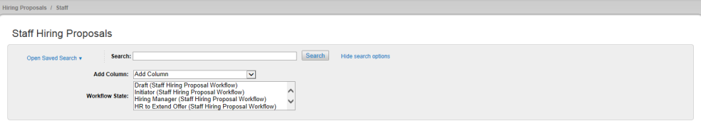

* Here, you will still be able to apply your keyword (Name), but will also have expanded functionality to include adding columns to your dynamic query. To add a Column, select the

column of data from the Add Column drop down box. You may add multiple columns by continuing your selections. Your query will automatically update and expand with the new columns included

* Choose a Workflow State for Hiring Proposals in process
* After completing your search parameters, click on “Search” to update your query

**To** Save a Search **for later use and recall:**

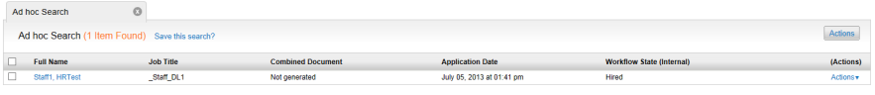

* Choose “Save this search?” from the results section below the search boxes

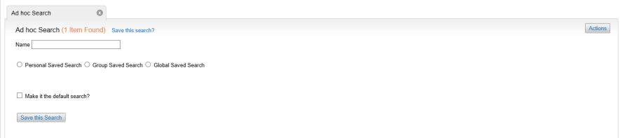

* Name your Search and indicate by clicking the radio button (where permitted) if the Saved Search will be available to only you (Personal Saved Search) or other groups of users (Group Saved Search). Human Resources will have the capability to create a “Global Saved Search”
* Indicate if the Saved Search should be your default view(i.e., the view of information that displays each time visit the Postings area)
* When done, click on 
* Saved Searches are saved as a tab on the Job Applications screen next to all other default and ad-hoc search queries

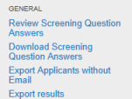 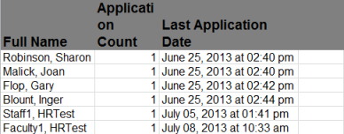

* Choose the Action button above the Search results and select “Export Results”. The system will ask if you would like to Save or Open your export results in Excel

On screen, Columns may be moved, sorted and deleted hovering over the column title and clicking on the representative function:

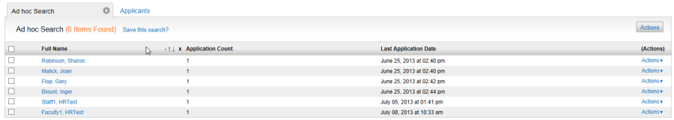

* Where available, each column may be moved to another location on the query by selecting the horizontal arrows and shifting them to the right or left
* Data may be sorted by clicking on the ascending or descending vertical arrows
* Columns of data may be deleted by clicking on the “x” above the column

**To** Export Results **to Excel:**

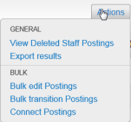 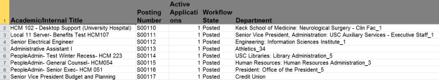

* Choose the Action button above the Search results and select “Export Results”. The system will ask if you would like to Save or Open your export results in Excel

On screen, Columns may be moved, sorted and deleted hovering over the column title and clicking on the representative function:

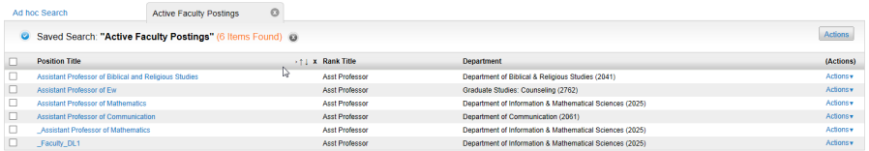

* Where available, each column may be moved to another location on the query by selecting the horizontal arrows and shifting them to the right or left
* Data may be sorted by clicking on the ascending or descending vertical arrows
* Columns of data may be deleted by clicking on the “x” above the column