Setting Up Guest Users in the Messiah College Online Recruitment System

Guest Users, in the Messiah College Online Recruitment System, are set up as users who have permission to view only specific job postings and applications for those postings. Guest Users may or may not be Messiah College employees. Note that single-sign-on (SSO) capabilities are not extended to Guest Users and each guest invitation will generate a username and random password.

Guest User accounts are unique to a posting and, since they are not authorized to take any action with the system or be assigned to a Search Committee, multiple Guest Users may have the same username/password. Passwords may be changed during the Guest User set up process. Guest Users are notified of their invitations by an email communication for each assigned job posting. Guest User access is terminated automatically when the posting is filled.

Human Resources administrators are also permitted to set up Guest Users.

To set up a Guest User:

* Create a new Staff or Faculty Posting or edit an existing Staff or Faculty Posting
* On the Editing Posting screen, select Guest User from navigation menu at the left of the page
* Select  if you would like to give guests access to view the posting

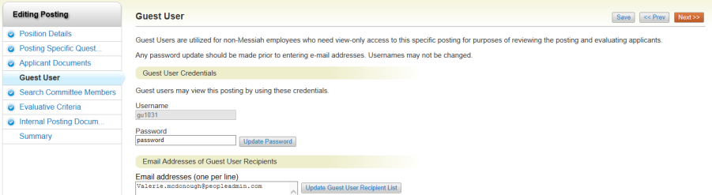

* The Guest User username defaults to a random log on credential; the password is also random but may be changed for the Guest User recipient. If changed, the password change must occur prior to selecting Update Guest User Recipient List
* Add an email address to the Email Address Box. When done, select , then, Next. Choose Save or continue editing your Posting

***One more step…***Activate the Guest User by returning to the Job Posting Summary Page and selecting “Activate Guest User” from the menu on the right.

