Unit 5
Content: school supplies, classroom, social phrases

School Supplies

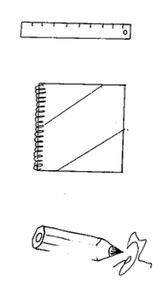
Match:
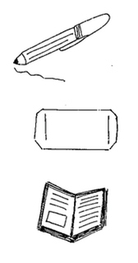
pencil

pen

ruler

notebook

eraser

book

Choose a word:

pencil erase r notebook
1. I write with my _______________.

2. I write in my ________________.

3. I erase with my ________________.
Review Greetings

Choose a word:

you morning are fine

Teacher: Good _____________! How are ______ today?

Student: I’m __________ teacher. How ________ you?

Match:

The pencil goes in the book bag.

The book goes in the classroom.

The student goes in the pencil case.

Review Polite Words

Choose a word:

you please You’re

Jane: May I borrow your eraser ____________?

Christina: Sure.

Jane: Thank _________.

Christina: ___________ welcome.
Classroom
Label:

wall door chair desk table

chalkboard window light

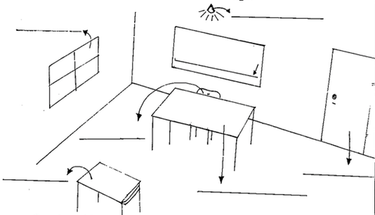

Complete with a word above:

1. I sit in my _____________.

2. I sit at my _____________.

3. The teacher writes on the ___________________.

4. We turn on the ______________.

5. We come in through the _____________.
Review Partings

Fill in the missing letters:

g __ __ d b __ e

s __ __ y __ u l __ t __ __

s __ e __ o u n __x __ w __ e __

Review School Supplies

Color as your teacher says:
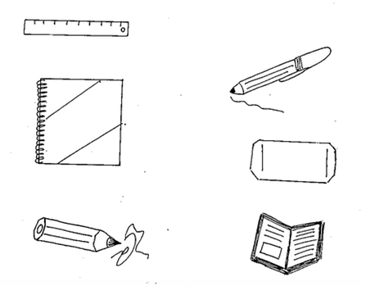
Sing!

Read and Pray

Read your Bible, pray every day, pray every day

Read your Bible, pray every day, and you’ll grow, grow, grow

And you’ll grow, grow, grow (2x)

Read your Bible, pray every day, and you’ll grow, grow, grow

Don’t read your Bible, forget to pray, forget to pray, forget to pray

Don’t read your Bible, forget to pray, and you’ll shrink, shrink, shrink

And you’ll shrink, shrink, shrink (2x)

Don’t read your Bible, forget to pray, and you’ll shrink, shrink, shrink

I Choose to Follow

God created our bodies, He created our minds

We are unique, we are mankind

God made us free to follow or not

To obey His word, and all that He taught

I choose to follow, to follow my Lord (4 x)

